EXPT NO:6 | OVER-PLOTTING REDUCTION TECHNIQUES
Roll No 23BAD078 | OVER-PLOTTING REDUCTION TECHNIQUES
DATE: 09.02.2026 | OVER-PLOTTING REDUCTION TECHNIQUES

PRE-LAB QUESTIONS

- Why is over-plotting common in big data visualization?

Answer: Because large datasets contain many points that overlap within limited visual space, especially in scatter and line plots.

- How does data density affect perception?

Answer: High data density hides patterns, clusters, and outliers, making trends harder to interpret.

- What trade-offs exist between detail and clarity?
Answer: More detail shows individual data points but causes clutter; more clarity simplifies data but hides variations.

- How do AI datasets increase visualization complexity?

Answer: AI datasets are large, high-dimensional, and unstructured, leading to clutter and over-plotting.

- Why is over-plotting a serious analytical risk?

Answer: It can hide true patterns and mislead analysis, resulting in wrong conclusions.

OBJECTIVE : To apply techniques that reduce visual clutter in large-scale datasets.

SCENARIO A social media analytics company visualizes millions of user interactions to study engagement patterns.

IN-LAB TASKS (Using R Language) • Apply alpha blending • Implement jittering techniques • Use aggregation and binning

CODE:

print("Roll No: 23BAD078")

library(ggplot2)
library(dplyr)

data <- read.csv("7.social_media_interactions.csv")
ggplot(data, aes(x = Likes, y = Comments)) +
geom_point(alpha = 0.3) +
labs(title = "Alpha Blending to Reduce Over-Plotting",
x = "Likes",
y = "Comments")
ggplot(data, aes(x = Likes, y = Shares)) +
geom_jitter(alpha = 0.4, width = 0.3, height = 0.3) +
labs(title = "Jittering to Separate Overlapping Points",
x = "Likes",
y = "Shares")
ggplot(data, aes(x = Likes, y = Comments)) +
geom_bin2d() +
labs(title = "2D Binning of Engagement Data",
x = "Likes",
y = "Comments")

agg_platform <- data %>%
group_by(Platform) %>%
summarise(
avg_likes = mean(Likes, na.rm = TRUE),
avg_comments = mean(Comments, na.rm = TRUE),
avg_shares = mean(Shares, na.rm = TRUE)
)

ggplot(agg_platform, aes(x = Platform, y = avg_likes)) +
geom_bar(stat = "identity") +
labs(title = "Average Likes by Platform",
x = "Platform",
y = "Average Likes")
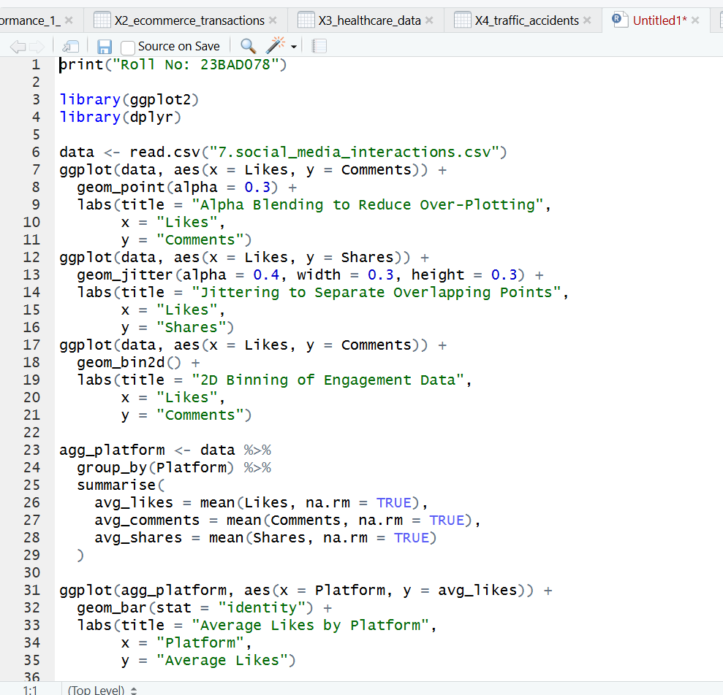
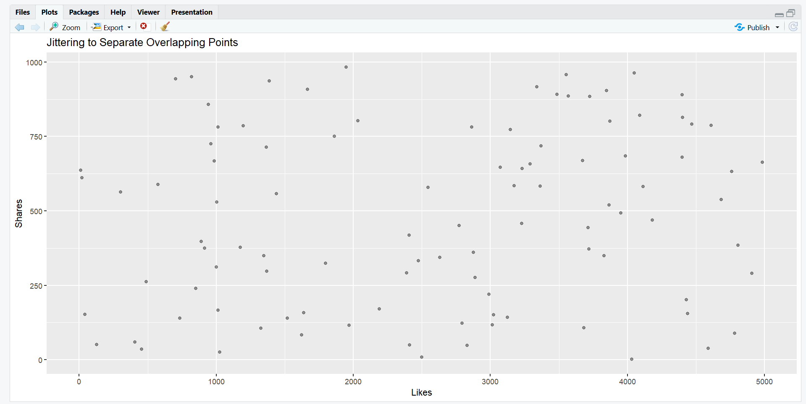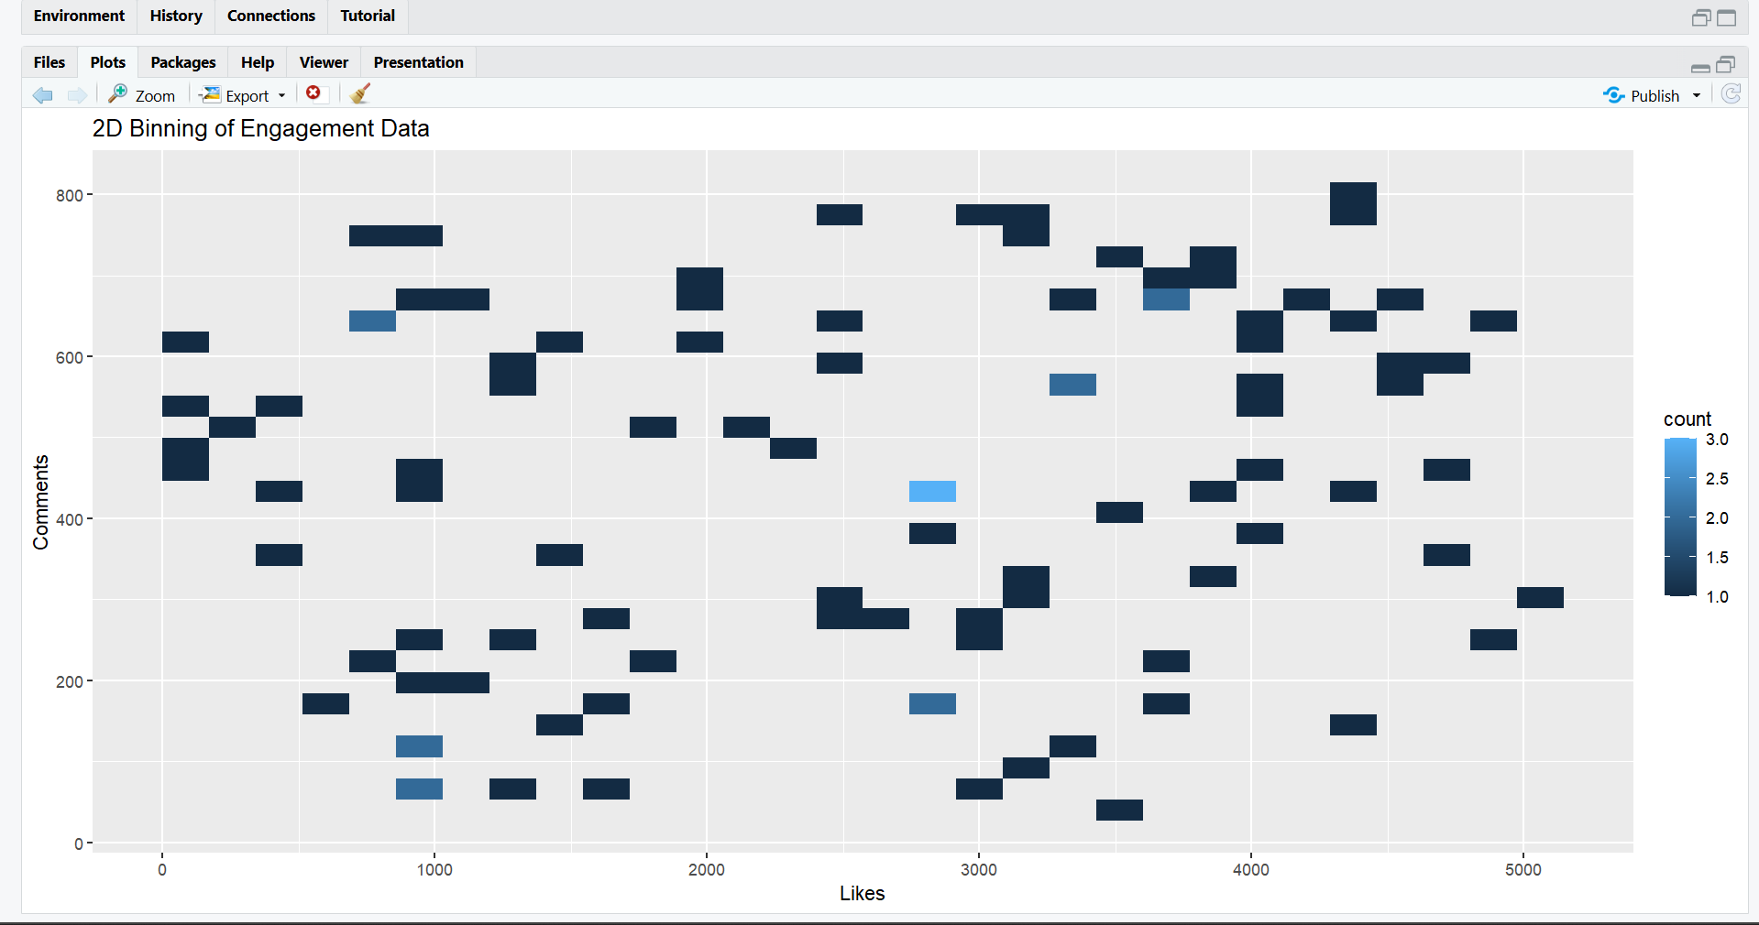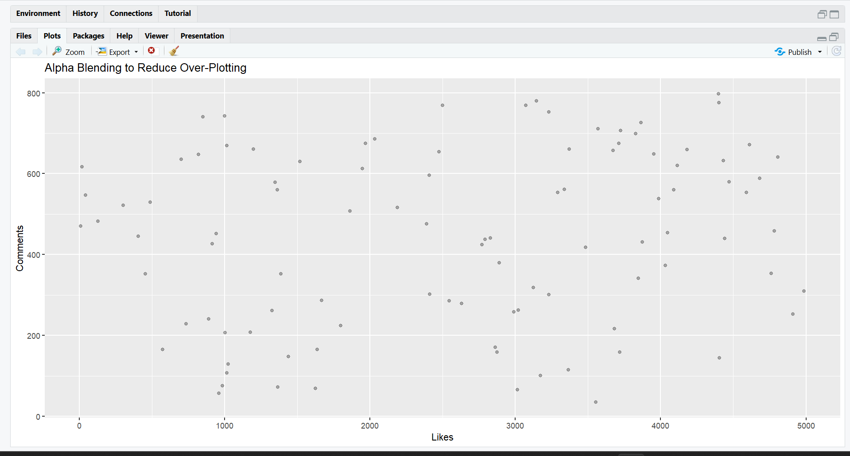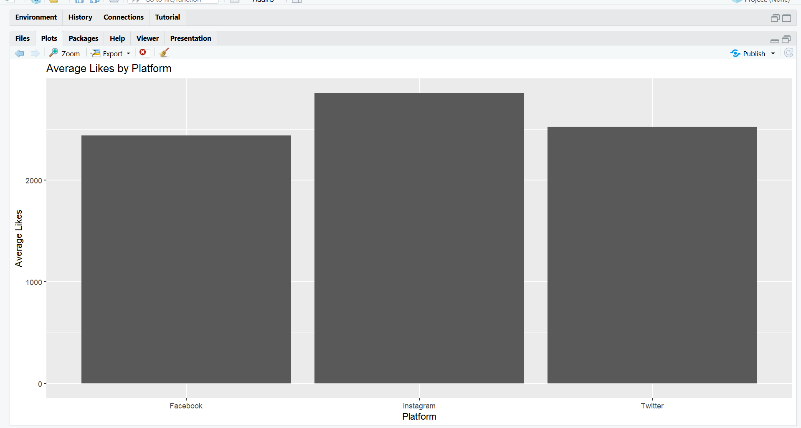

POST-LAB QUESTIONS
- Which technique provided the best clarity and why?

Answer: Aggregation and binning provided the best clarity because they summarize dense data and clearly show overall patterns.

- How does over-plotting distort analytical conclusions?

Answer: Over-plotting hides trends and outliers, leading to false patterns and incorrect insights.

- When should aggregation be preferred over raw plotting?

Answer: Aggregation should be used when datasets are very large and individual data points are not important.

- How do these techniques support scalable AI analytics?

Answer: They reduce data complexity, improve interpretability, and enable efficient analysis of large AI datasets.

- Explain real-world consequences of ignoring over-plotting.

Answer: Ignoring over-plotting can cause wrong business decisions, poor predictions, and misleading AI models.

LEARNING OUTCOME: Students master over-plotting reduction for big data visual analytics.
ASSESSMENT
Description | Max Marks | Marks Awarded
Pre Lab Exercise | 5
In Lab Exercise | 10
Post Lab Exercise | 5
Viva | 10
Total | 30
Faculty Signature

